

Technical Support and E-Warranty Certificate www.vevor.com/support

Patio Dining Sets
（Long table）
USER MANUAL

We continue to be committed to provide you tools with competitive price.
"Save Half", "Half Price" or any other similar expressions used by us only represents an
estimate of savings you might benefit from buying certain tools with us compared to the major
top brands and doses not necessarily mean to cover all categories of tools offered by us. You
are kindly reminded to verify carefully when you are placing an order with us if you are
actually saving half in comparison with the top major brand



Patio Dining Sets
（Long table）

Model: WS-SS-002
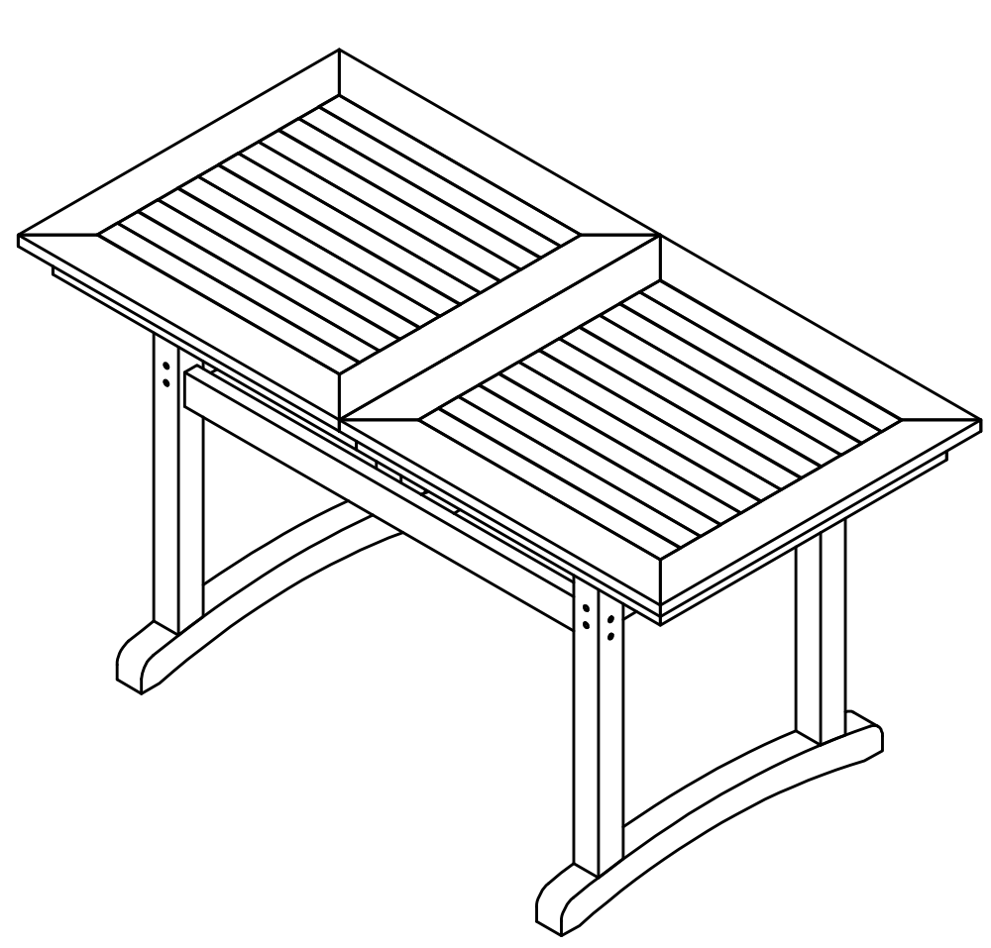

Note:Please be patient that the other itemsare on the way if you buy more than one product.

Have product questions? Need technical support? Please feel free to contact us:
CustomerService@vevor.com
NEED HELP? CONTACT US!
This is the original instruction, please read all manual instructions carefully before operating. VEVOR reserves a clear interpretation of our user manual. The appearance of the product shall be subject to the product you received. Please forgive us that we won't inform you again if there are any technology or software updates on our product.

PRODUCT PARAMETERS

Model | Product Size(LxWxH） | Loading Capacity | material | Color
WS-SS-002 | L70.8" xW31.5"xH34.8"  (1800x800x755mm) | 300 lbs (Max)  (about 150KG) | Wood-Plastic Composites | Black

ASSEMBLYPRECAUTIONS

ASSEMBLY PRECAUTIONS

1. Assemble needs to follow these instructions. Incorrect assembly can be a hazard.
2. Wear safety goggles and heavy-duty work gloves during assembly.
3. Do not assemble when tired or when under the influence of alcohol, drugs or medication.
4. Weight and other product properties are only applicable to correctly and completely assembled products.
5. Keep the assembly area clean and well-lit.
6. Keep bystanders out of the area during assembly.

USE PRECAUTIONS

WARNING: TO PREVENT SERIOUS INJURY AND DEATH FROM TIPPING:
- This product is not a toy.Please keep theproduct away from children while assembling.
2. Use as intended only. Do not let children play or jump on the product.Do not stand on the item or use as a step ladder.
3. Inspect before every use. Do not use it if parts are loose or damaged.
4. Tighten the lower screws every three months to prevent loosening of the legs.
5. Do not exceed the listed weight capacity. Tighten all knobs securely before applying load. Be aware of dynamic loading! The sudden load movement may briefly create an excess load, causing product failure.
6.These all-weather items can be stored outdoors year-round.Perfect for people who lives in a wet climate or lives on the coast where humidity and moisture will be an issue all year

SAVE THESE INSTRUCTIONS

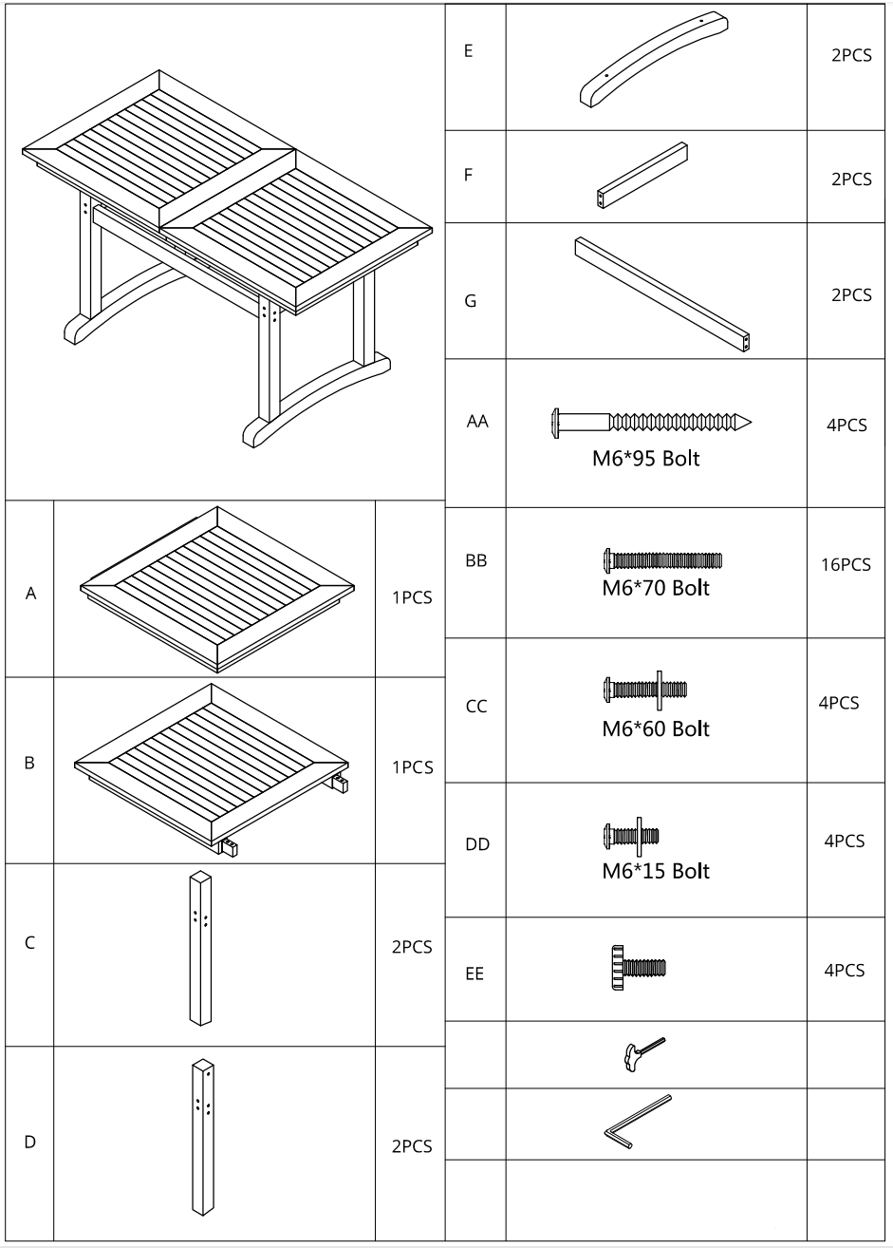
PARTS LIST

ASSEMBLY STEPS

STEP1

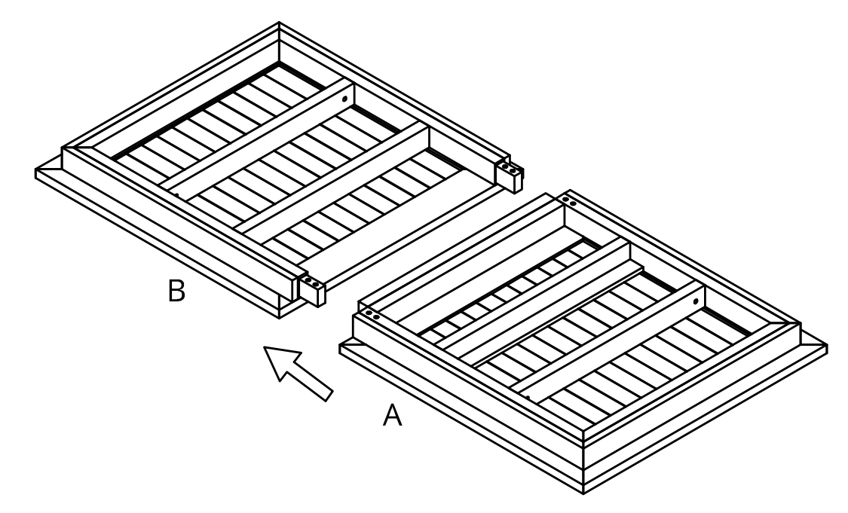

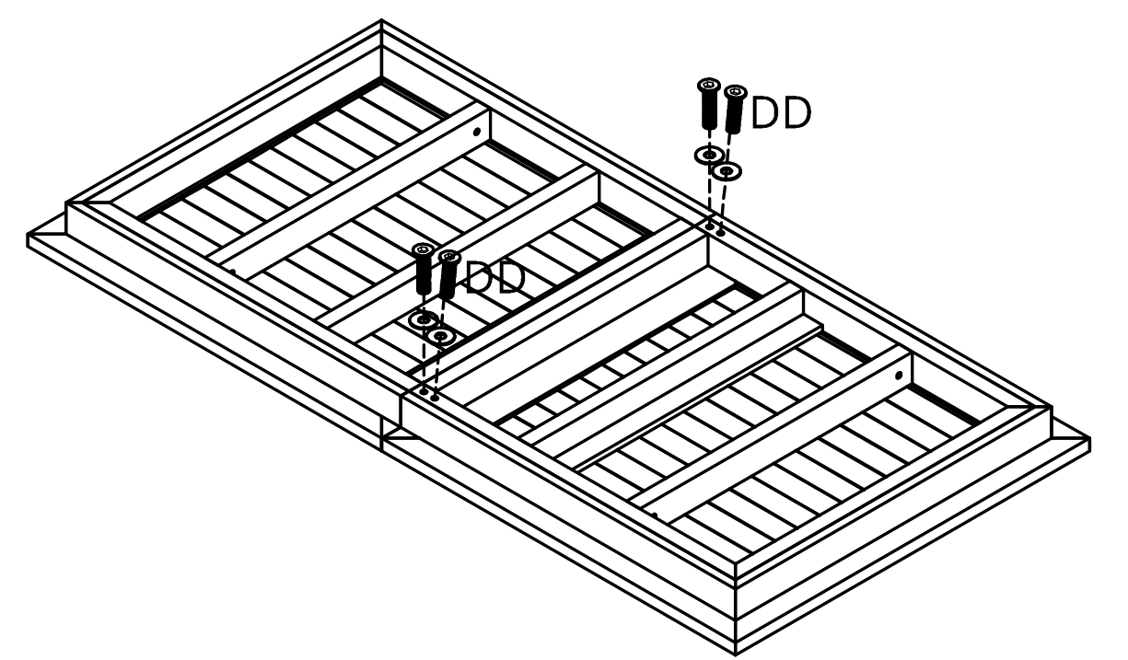

STEP2

STEP3

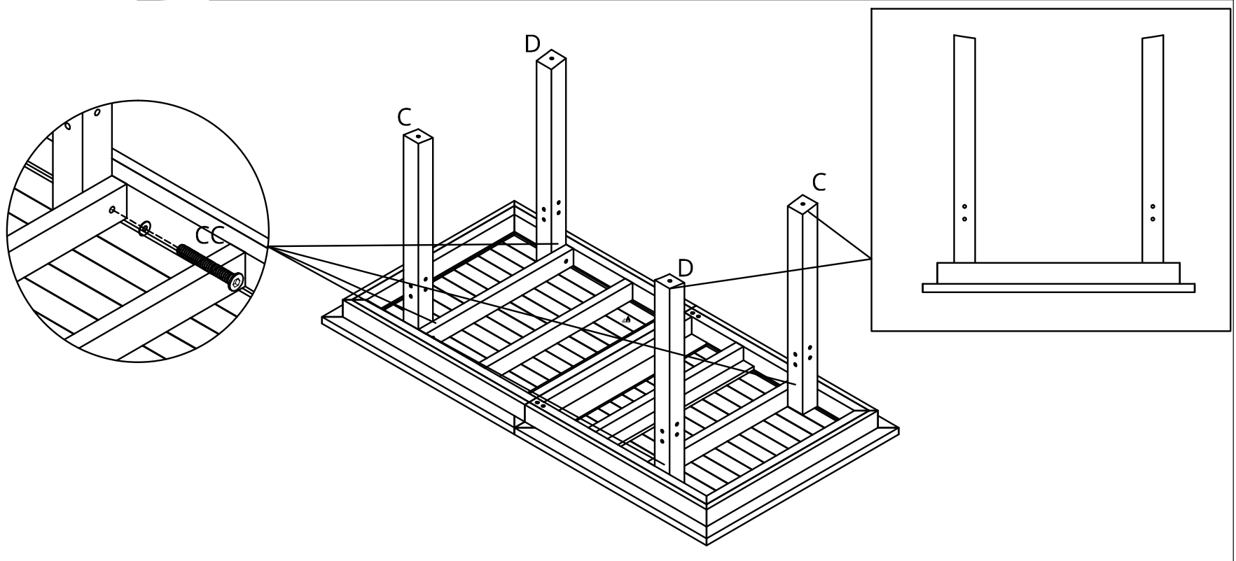

STEP4
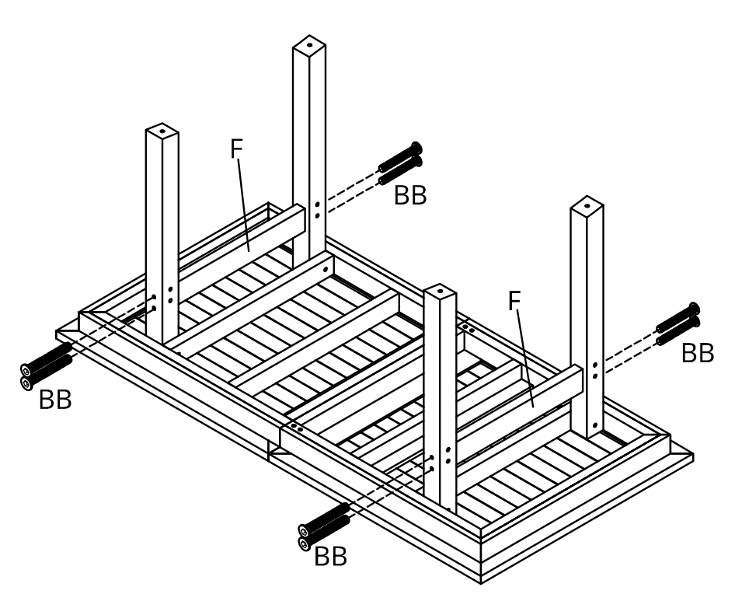

STEP5

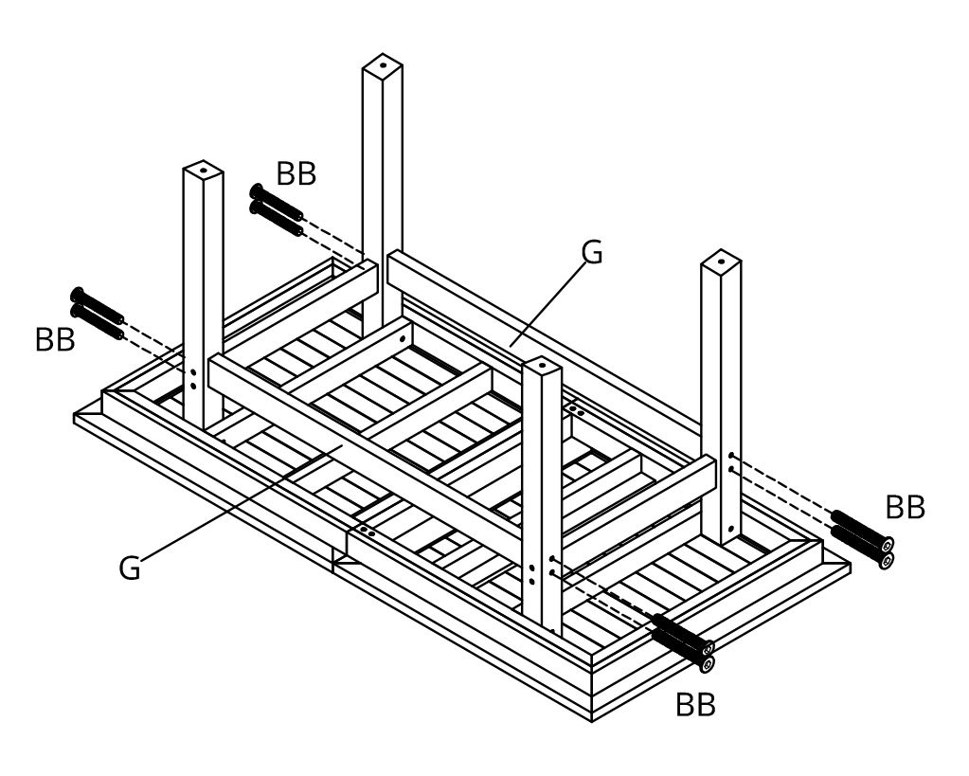

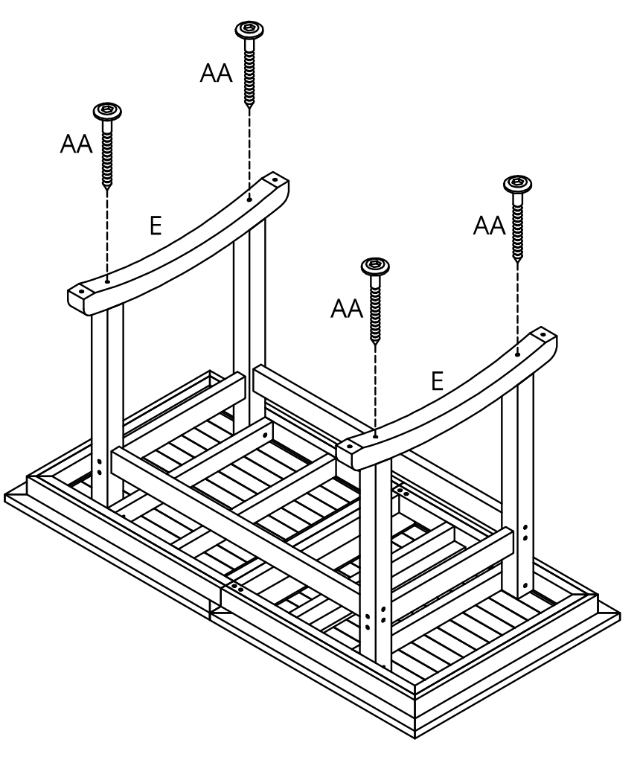

STEP6

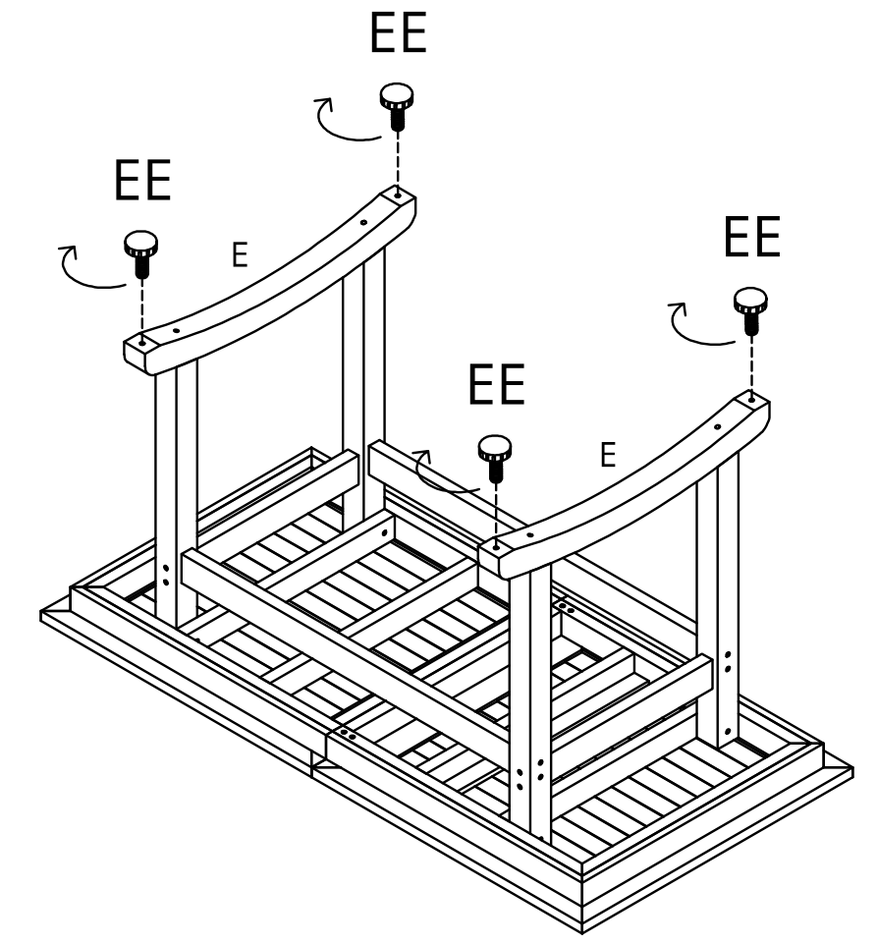
STEP7

COMPLETION

Cleaning and Maintenance
-Use a soft, clean cloth that will not scratch the surface when dusting.
- If you run into scratches problems,wesuggest you erase the scratches by knife.
-This item could be cleaned with soap andwater.Be sure to avoid harsh solvents and abrasives.
- Periodically (every 90 days) makesure the screws are fully tightened.

Sanven Technology Ltd.
Address: Suite 250, 9166 Anaheim Place, Rancho Cucamonga, CA 91730

Made in China

Support and E-Warranty Certificate
www.vevor.com/support

