

Technical Support and E-Warranty Certificate www.vevor.com/support

BONE SAW MACHINE
USER MANUAL

Model: HC-210 HC-250 HC-280
We continue to be committed to provide you tools with competitive price.
"Save Half", "Half Price" or any other similar expressions used by us only represents an estimate of savings you might benefit from buying certain tools with us compared to the major top brands and doses not necessarily mean to cover all categories of tools offered by us. You are kindly reminded to verify carefully when you are placing an order with us if you are actually saving half in comparison with the top major brands.


BONE SAW MACHINE

HC-210 HC-250 HC-280

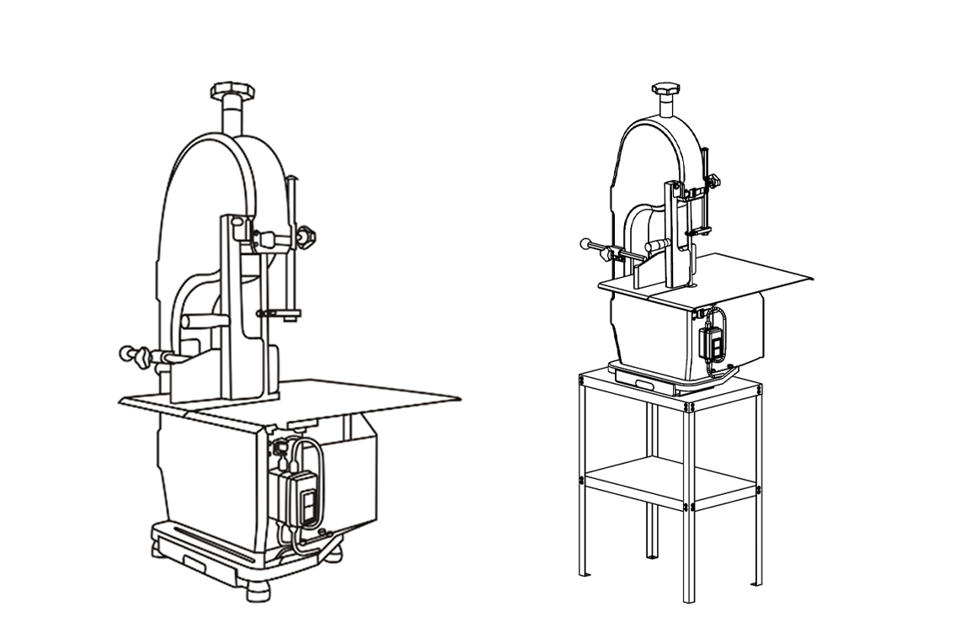

Have product questions? Need technical support? Please feel free to contact us:
CustomerService@vevor.com
NEED HELP? CONTACT US!
This is the original instruction, please read all manual instructions carefully before operating. VEVOR reserves a clear interpretation of our user manual. The appearance of the product shall be subject to the product you received. Please forgive us that we won't inform you again if there are any technology or software updates on our product.
Bone Sawing Machine adopts the world’s advanced technology and is well-designed for meat and bone processing. It is characterized by high efficiency, low energy consumption, easy operation, elegant appearance, etc. Bone Sawing Machine is ideal for sawing meat, bones, poultry, and fish. It is widely used in hotels, restaurants, food processing factories, and slaughterhouses. Bone Sawing Machine adopts stainless steel on the appearance and spare parts of the machine, and special surface treatment is applied on the food contacting surface. The machine follows the National Food Safety Standard.

IMPORTANT SAFEGUARDS
WARNING:
Read all safety warnings, instructions, illustrations and specifications provided with this electrical appliances. Failure to follow all instructions listed below may result in electric shock, fire and/or serious injury.
1. There shouldn't be anything else on the counter.
2. There is no abnormal phenomenon after the power is switched on .
3. It must be placed on the horizontal plane to avoid danger from shaking back and forth during use.
4. Because the chain saw rotates at high speed, it is also necessary to develop the habit of turning off the switch when the operation is suspended. Do not plug the power cord into the socket when not in use. Please unplug the power cord after use and before cleaning or maintenance.
5. If iron nails or other metal items are included in the cut items, it will cause jagged cracks or damage. So, please pay attention to the cutting surface during operation to ensure workplace safety.
6. Please unplug the power of the machine before cleaning, assembling or disassembling.
7. Do not place the product within reach of children. Children should be supervised to ensure they do not play with the appliance.
8. This appliance can be used by children aged from 8 years and above and persons with reduced physical, sensory or mental capabilities or lack of experience and knowledge if they have been given supervision or instruction concerning use of the appliance in a safe way and understand the hazards involved. Children shall not play with the appliance. Cleaning and user maintenance shall not be made by children without supervision.
9. Don't unplug the machine before it stops operation.
10. If the supply cord is damaged, it must be replaced by the manufacturer, service agent, or similarly qualified persons to avoid a hazard.
11. Electric Shock Danger! Non-professional personnel is forbidden to repair the products. Otherwise, it may result in electrical shock. When failures happen, they should be fixed by qualified maintenance personnel.
12. WARNING! Putting the main body into the water to clean is strictly prohibited. It only can be scrubbed with a wet towel. The machine must be thoroughly cooled before cleaning.
13. Please check that the specified supply voltage in the product is consistent with the supply voltage(AC only).
14. Avoid power cord damage. Do not squeeze, bend, or friction; keep it away from heat sources and open fires. The power cord does not touch the blade.
15. Power cord should be laid fiat. Do not pull the power cord and make the product fall, which may cause damage.
16. Do not use the product on wet ground. Do not touch the product or power cord plug with wet hands.
17. Do not disassemble the product at will. Also, do not let something enter or insert into the product, which may cause damage.
18. Only accessories the seller or manufacturer provides can be used for the product. We will not be responsible for any failure caused by using accessories from other manufacturers not covered by warranty.
19. Do not use the product on uneven, damp, not heat-resistant surfaces to avoid damage or failure.
20. Do not place the product directly on the fire or near the source of the fire. Otherwise, the product will be damaged or even result in danger.
21. When the plug is plugged into the socket, it must be plugged into the end. Otherwise, it will cause the components to overheat and burn due to poor contact.
22. Do not leave the product to work with no one watching. If the machine is overheating, please stop working immediately and unplug the power.
23. Once part of the product is on fire, do not directly use water to extinguish the fire. Use a wet cloth to cover the fire site.
24. Please store the plastic bags and not allow children to play with them to prevent a risk of suffocation.
25. It is prohibited to put the main body of the machine and the power cord into any liquid.
26. DO NOT open the case door; the hands are strictly forbidden from touching the saw blade while the machine operates.
SAVE THESE INSTRUCTIONS

Method of Application
1. Move the guide block to the correct height according to the size, then fix it.
2. Adjust the thickness adjustment plate according to the required meat size.
3. Press the green button on the power switch. Do not push the sawed item too much during the operation. This will cause the saw bar to fall off or be damaged.
4. The operator should stand before the machine and push the product horizontally and straight.
5. The serrate should be exposed outside the wheel when replacing the saw blade.
6. The side of the saw blade presses the looseness of the saw blade with the force of rebound.
7. Turn the upper wheel with your hand. Run the saw blade in and adjust the screw counterclockwise. Run the saw blade out and change the screw clockwise.

Cleaning
The machine must be cleaned up after completion because the meat residue and foam attached to the body will not be hygienic for a long time. The next time you use it, the noise increases, and the saw blade is easily damaged.
Diagnosis and repair of faults
1. Chainsaw often breaks
Reason: a. The band saw is of poor quality b. The band saw is too tight c. Overpush or improper use, It is not direct push.
Repair: a. Use a good band saw. b. Adjust the band saw properly and adjust the handle make sure the band saw is not too tight. This is because the side of the saw blade presses the looseness of the saw blade with the force of rebound.
2. Departure with band saw
Reason: a. band saw is too loose. b something attached to the pulley. c. Improper use Repair: a. Adjust the handle of the band saw properly so that it does not loosen too easily. b. Remove the thing attached to the pulley. c. Use correctly.
3. Other malfunctions
Consult the agent, and please do not repair it by yourself. During the warranty period, the company is not responsible for the warranty of motor losses caused by improper operation, such as(water intake, lack of phase)
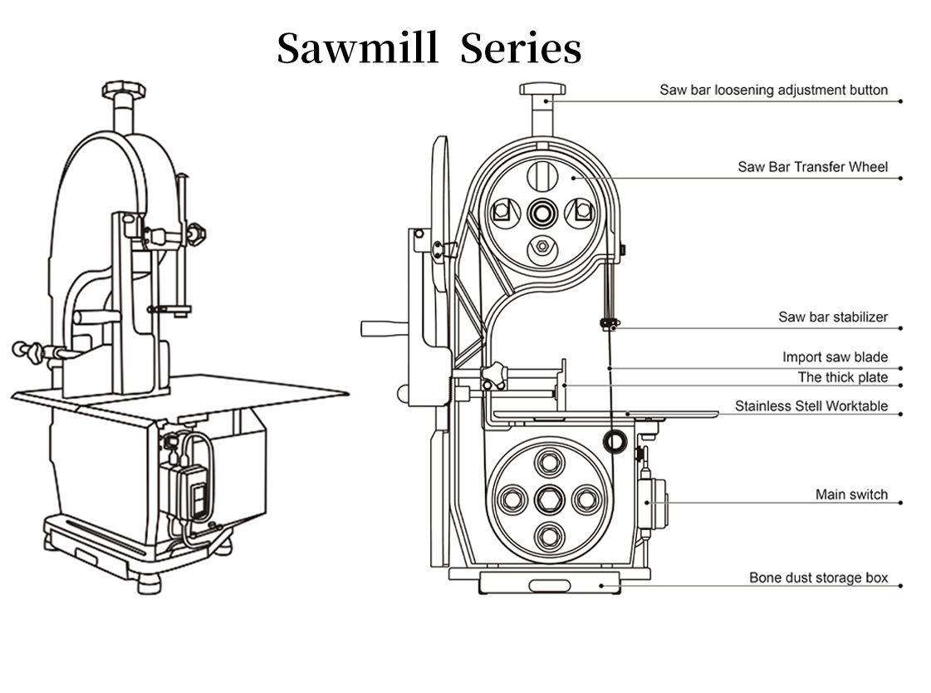
Model No. | Voltage | Power | Saw Blade Linear Velocity | Cutting thickness | PLUG TYPE
HC-210 | AC110-120V/60Hz | 1100W | 13m/s | 4-180mm | USA
HC-210 | AC220-240V/50Hz | 1100W | 13m/s | 4-180mm | EU
HC-210 | AC220-240V/50Hz | 1100W | 13m/s | 4-180mm | AUS
HC-250 | AC110-120V/60Hz | 1500W | 15m/s | 4-180mm | USA
HC-250 | AC220-240V/50Hz | 1500W | 15m/s | 4-180mm | EU
HC-250 | AC220-240V/50Hz | 1500W | 15m/s | 4-180mm | AUS
HC-280 | AC110-120V/60Hz | 1500W | 15m/s | 4-180mm | USA
HC-280 | AC220-240V/50Hz | 1500W | 15m/s | 4-180mm | EU

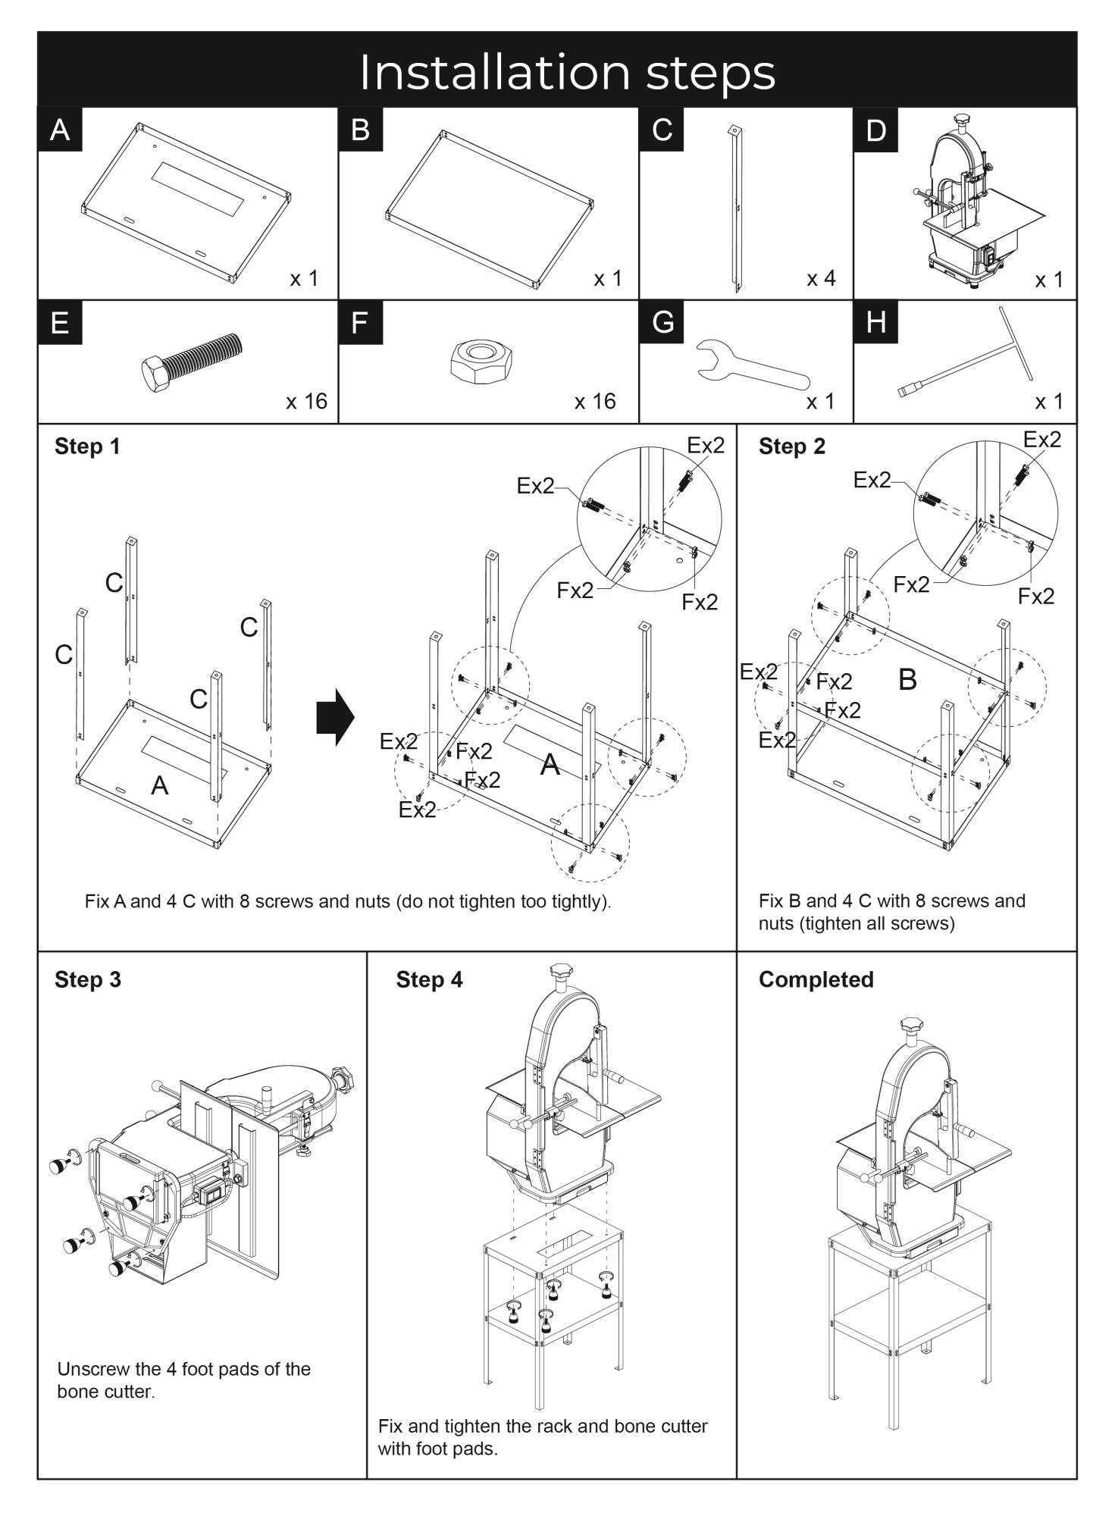
Electrical schematic diagram
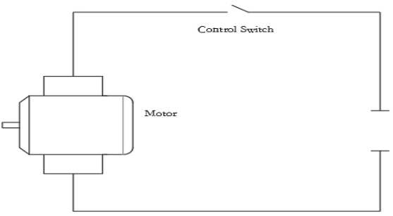
AC-IN

Correct Disposal

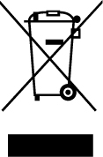 | This product is subject to the provision of European Directive 2012/19/EC. The symbol showing a wheelie bin crossed through indicates that the product requires separate refuse collection in the European Union. This applies to the product and all accessories marked with this symbol. Products marked with this symbol cannot be discarded with normal household waste but must be taken to an electrical and electronic equipment collection point for recycling.

Technical Support and E-Warranty Certificate
https://www.vevor.com/support

