

Technical Support and E-Warranty Certificate www.vevor.com/support

Golf Cart Cover
USER MANUAL

We continue to be committed to provide you tools with competitive price.
"Save Half", "Half Price" or any other similar expressions used by us only represents an estimate of savings you might benefit from buying certain tools with us compared to the major top brands and does not necessarily mean to cover all categories of tools offered by us. You are kindly reminded to verify carefully when you are placing an order with us if you are actually saving half in comparison with the top major brands.

Golf Cart Cover

Model:COV-20；COV-21
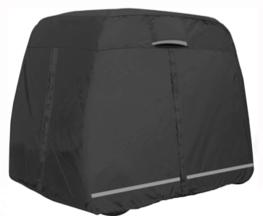

Thanks for purchasing one of our products, please read carefully the assembly instructions before the installation.

Have product questions? Need technical support? Please feel free to contact us:
Technical Support and E-Warranty Certificate
www.vevor.com/support
NEED HELP? CONTACT US!
This is the original instruction, please read all manual instructions carefully before operating. VEVOR reserves a clear interpretation of our user manual. The appearance of the product shall be subject to the product you received. Please forgive us that we won't inform you again if there are any technology or software updates on our product.
PRODUCT PARAMETERS
Product Name： | Golf Cart Cover
Product Material： | High density polyester 600D
Product Color： | Black
Model： | COV-20 | COV-21
Fits for  the chair size：(L*W*H) | 106"x48"x67" | 112"x48"x66"
Models： | 2 seats | 4 seats

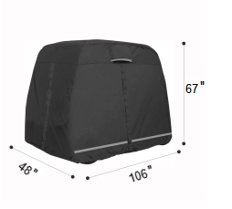 | 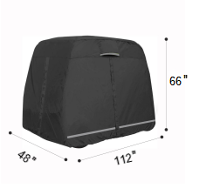
COV-20 | COV-21

General Safety Rules
WARNING:
Please read carefully the following instructions in order to reduce the risk of injuries, accidents or damage to the product by itself.
ASSEMBLY PRECAUTIONS
Do not assemble when tired or under the influence of alcohol, drugs or medication.

USE PRECAUTIONS
1.Use as intended only.
2.Before use, measure whether the size of the Golf Cart is within the scope of the product description.
3.Please don't put the product beside a heating plant or fires, or pour hot water on it in case of fires, burns and deformation dangers.
4.Please don't allow babies and children to put fragments of this product into their mouth.
5.There may be slight odor when unpacking. Please put the golf cart cover in a ventilated place to give off the odor.
6.Please do not put the product into the washing machine, it is recommended to wash by hand.
7.Please do not contact this product with corrosive chemicals and sharp knives.
8.This product is not a toy. Children and minors are not allowed to use this product to avoid causing personal injury
9.The safety precautions and instructions given in this manual are unable to cover in detail all the conditions and situations that may arise.
10.The operator and/or user must use common sense and caution when operating the product especially for any matters that are not referred in the above.

SAVE THESE INSTRUCTIONS

Installation Method
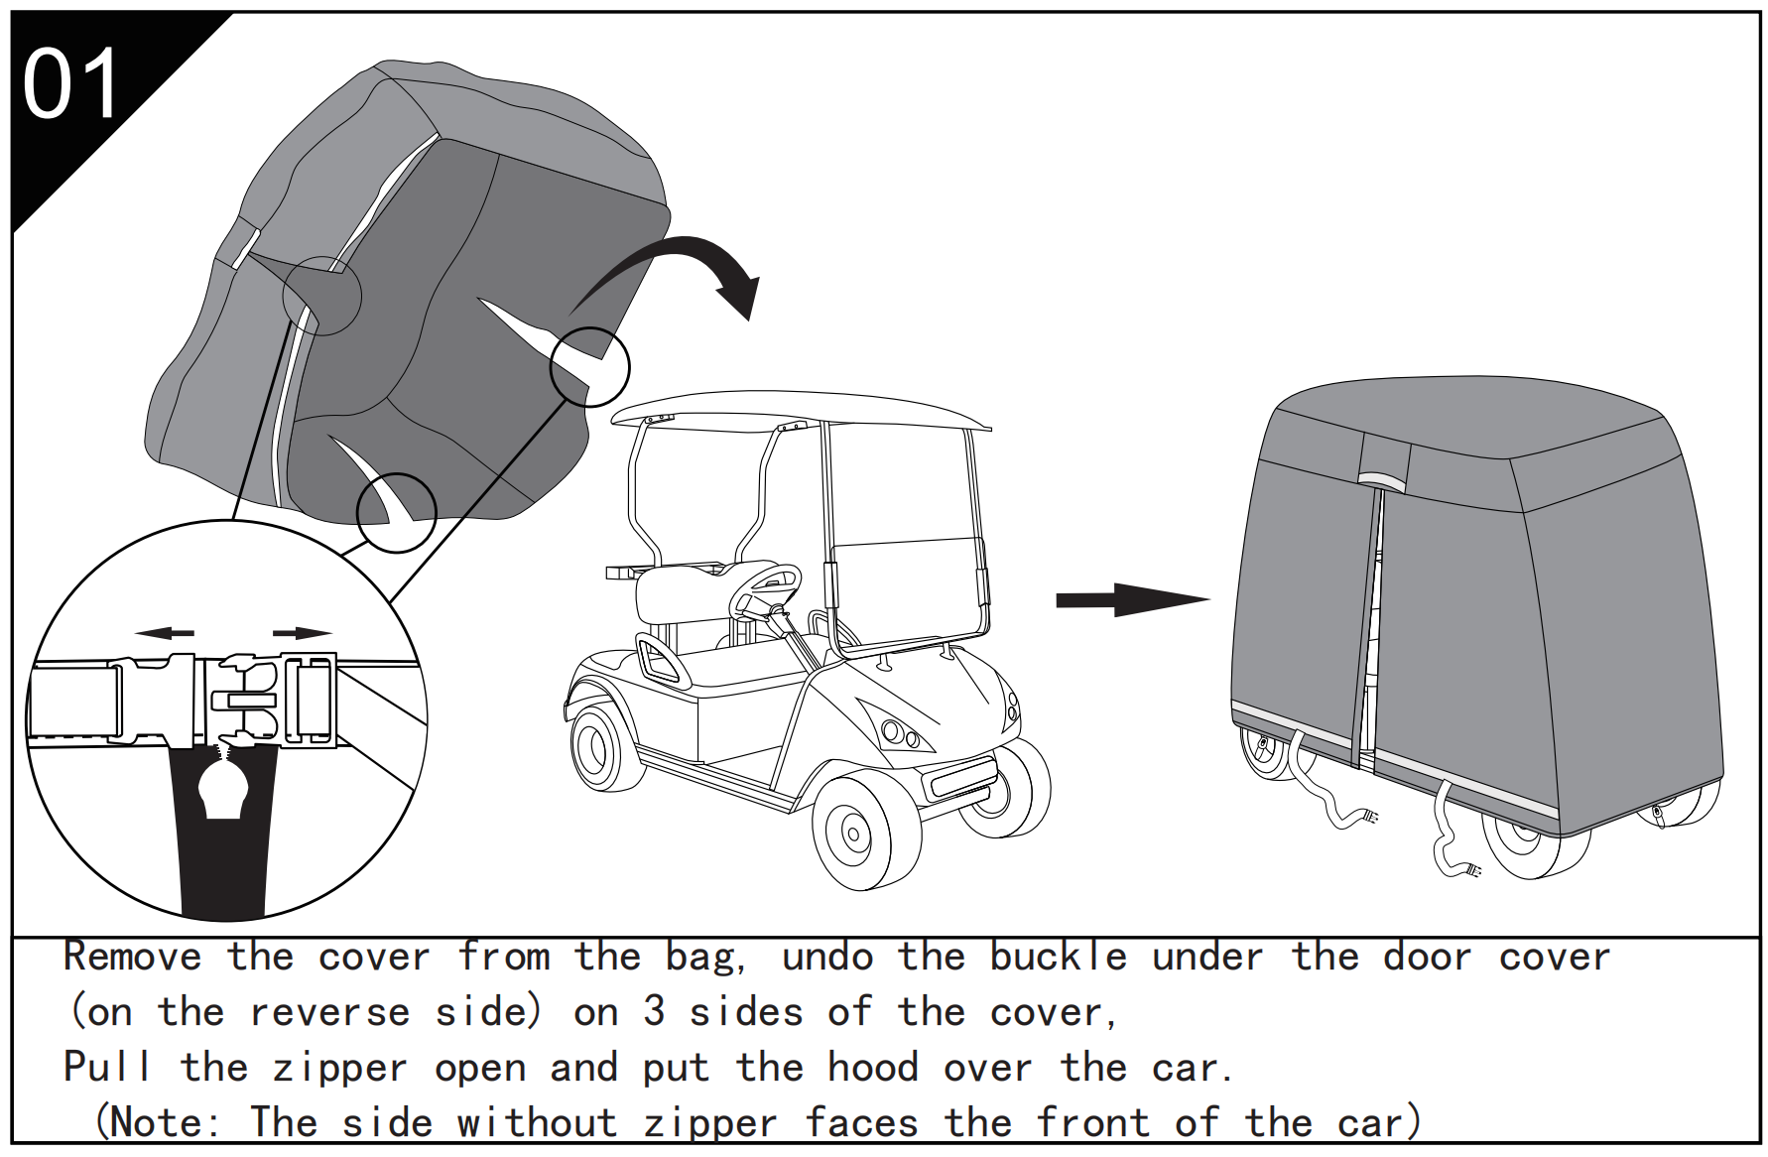
reverse side
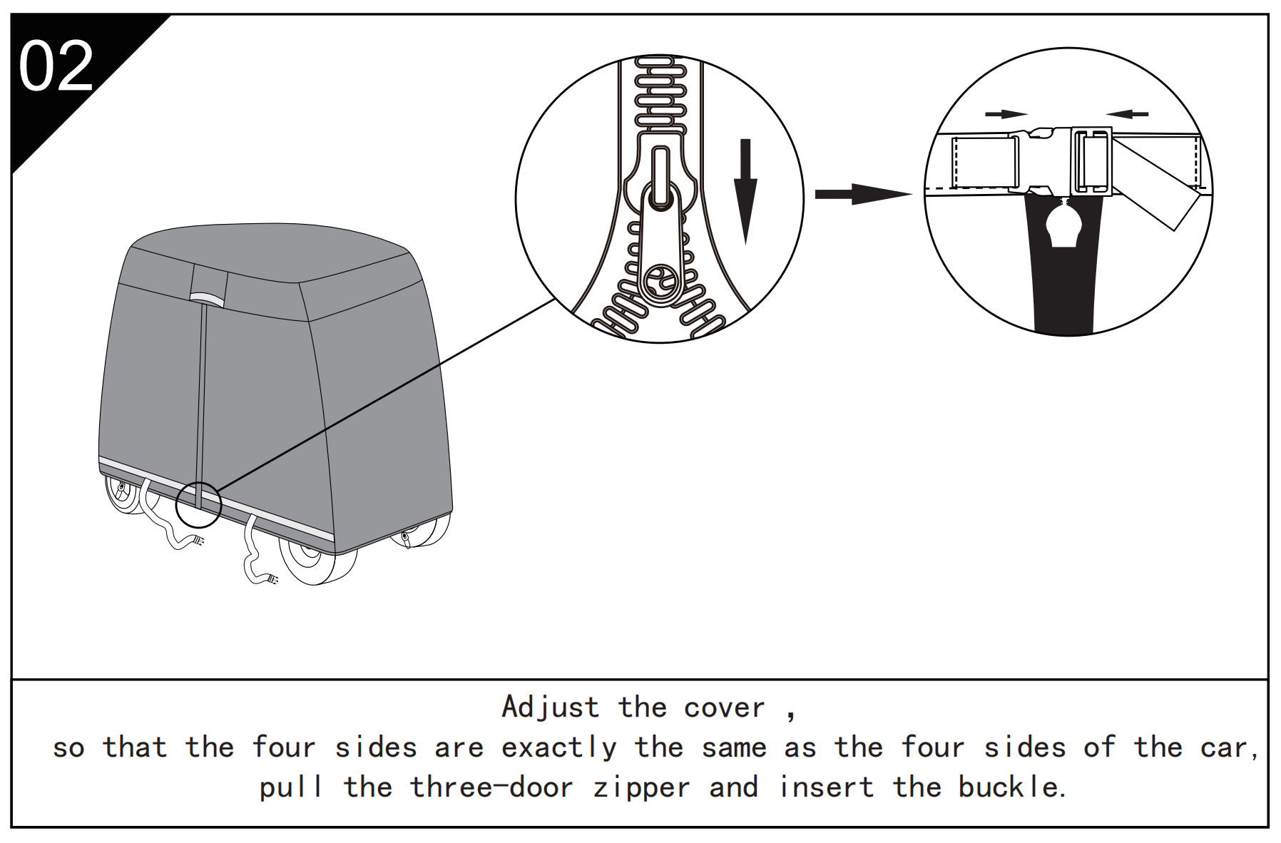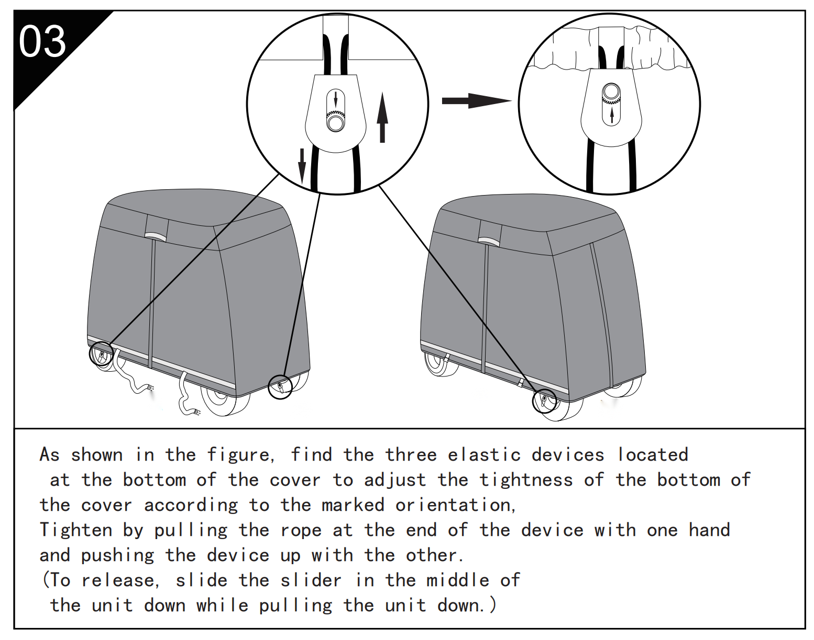
reverse side
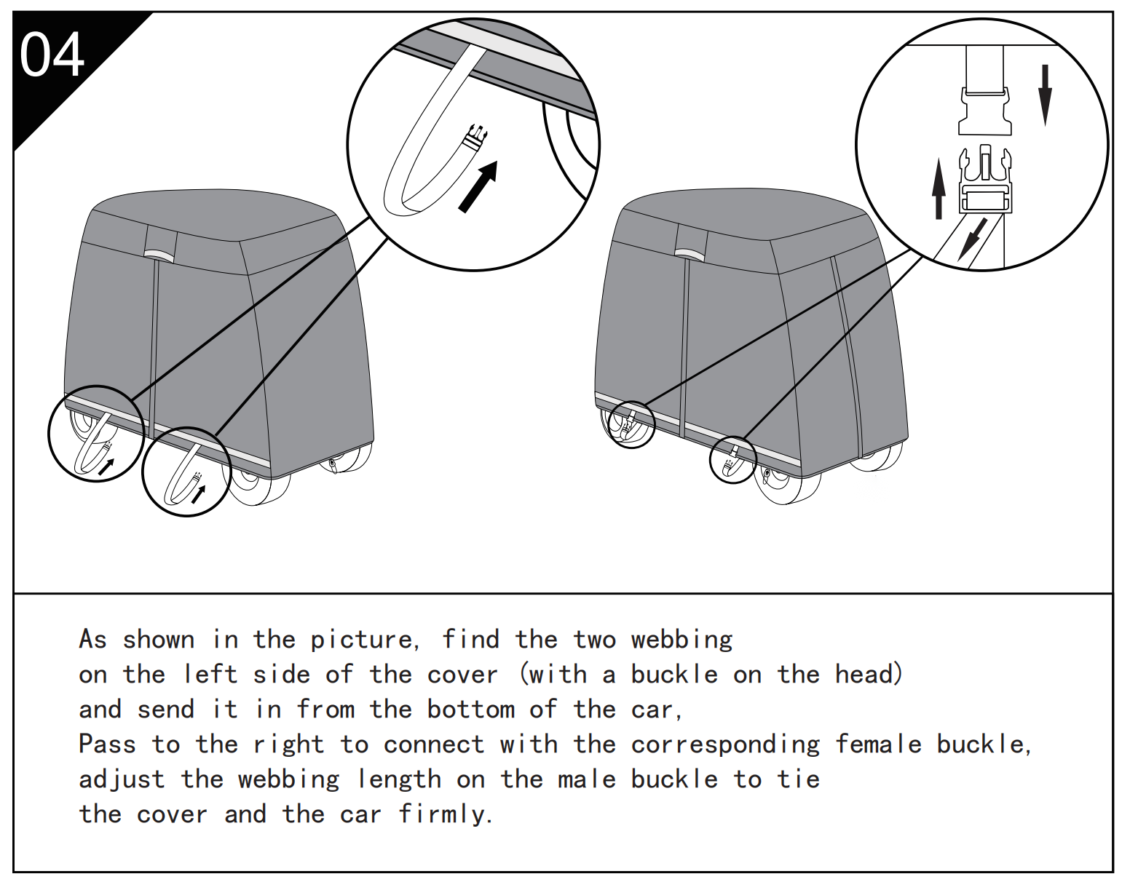
Cleaning
-Hand wash with laundry solution and let dry naturally.
Do not machine wash.

Sanven Technology Ltd.
Address: Suite 250, 9166 Anaheim Place, Rancho Cucamonga, CA 91730
Made in China

Support and E-Warranty Certificate
www.vevor.com/support

