

Technical Support and E-Warranty Certificate
www.vevor.com/support

MECHANICAL KEYLESS DOOR LOCK USER MANUAL

We continue to be committed to provide you tools with competitive price.
"Save Half", "Half Price" or any other similar expressions used by us only represents an estimate of savings you might benefit from buying certain tools with us compared to the major top brands and does not necessarily mean to cover all categories of tools offered by us. You are kindly reminded to verify carefully when you are placing an order with us if you are actually saving half in comparison with the top major brands.

MECHANICAL KEYLESS
DOOR LOCK
MODEL:OL-201D2-03
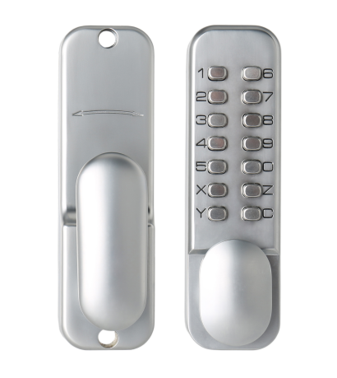
(The picture is for reference only; please refer to the actual object)

Have product questions? Need technical support? Please feel free to contact us:
Technical Support and E-Warranty Certificate
www.vevor.com/support
NEED HELP? CONTACT US!
This is the original instruction, please read all manual instructions carefully before operating. VEVOR reserves a clear interpretation of our user manual. The appearance of the product shall be subject to the product you received. Please forgive us that we won't inform you again if there are any technology or software updates on our product.
Safety instruction and precautions

- WARNING:
Read this material before using this product. Failure to do so can result in
serious injury.

Assembly precautions:
1)Assemble only according to these instructions. Improper assembly can
create hazards.
2)Wear ANSI-approved safety goggles and heavy-duty work gloves during
assembly.
3)Keep assembly area clean and well lit.
4)Keep bystanders out of the area during assembly.

NOTE:
1.Recommended password length is 4-6 digits.
2.Press the C key to reset before entering your password.
3.The password does not need to be entered in sequence.
4.Changing the password requires disassembly and replacement.

List of Parts
1) Lock Case
2) Back Plate
3) Neoprene Seals x2
4) Spindle
5) Latch(60mm or 70mm)
6) Striker Plate
7) Wood Screw x 4(Use with Latch & Striker Plate)
8) Bolt Guide
9) Tweezers ( For code setting)
10) Fixing Bolt(40m or 50mm ) x 2
11) Spare Code Tumblers
12) Code Card
MODEL:OL-201D2-03
BEFORE INSTALLATION PLEASE:
1) Ensure all parts work properly
2) Check and Ensure the supplied Code works. If you wish to change the code follow the instructions under " Changing the code" and confirm that it works.
3) Ensure that both knob handles of the Digital Lock can be moved freely.
Check that the hold-back function can be engaged and keeps the latch retracted
and handle pressed. Also check that the latch moves freely by pressing the end by
turning with the spindle.

INSTALLATION
1.APPLY THE TEMPLATE
Tape the template to the door. Make sure that you fold it along the appropriate line, depending on the back set of the latch 60mm.
Mark the 10mm diameter hole for the spindle of the Digital Lock,the two 7mm holes for the bolt though fixings.
Mark the correct 6mm diameter hole, for the reinforcement pin,depending on the handing of the door.
Drill all marked holes.

POSITIONING AND FIXING THE LATCH
Mark a central point on the 'Centre Line of Latch' on the door edge.Drill a 25mm hole x95mm deep.Insert the latch into the hole, and draw around the face plate.Remove the latch and cut a 3mm rebate so that the face plate
will fit flush with the door.Secure the latch with the wood screws.

2. LATCH SUPPORT POST
3. BLUE HANDING SCREW
When fitting a back-plate to a left-hand door the Blue screw must go on the right-hand hole and vise versa.
4.POSITIONING THE SPINDLE
Select the spindle to suit the thickness of the door.Insert the spindle through the slot in the door and make sure that it engages that latch correctly for the hand of the door (see inset diagram).
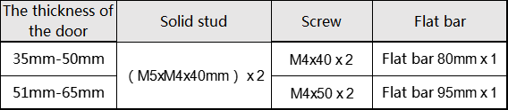
5. FIXING THE LOCK
Cut the fixing bolts to suit the door thickness,allowing at least one threaded section to screw into the lock-case.Hold the lock case and the back-plate, with the seals, onto the door with the spindle in position.
Using the fixing bolts screw everything together through the top and bottom holes of the back-plate.Before final tightening,make sure the lock is vertical,
and test the mechanism to ensure that it is all moving easily.
Do not close the door until you are sure that the code works.
Do not over tighten the fixing bolts as this may cause distortion and load to poor operation.
6.FITTING THE STRIKE PLATE
Position the strike plate on the door so that it lines up with the flat of the latch bolt,not the plunger.Make the inner and outer edges of the strike plate and cut a 1mm rebate so that it fits flush with the surface or the door frame.Drill or cut a recess for the latch bolt.Fit the strike plate using only one wood screw as first to ensure that it is positioned accurately.The latch bolt, and not the plunger, should enter the aperture easily, and be held without too mush 'play'. When satisfied secure the strike with the second screw.

CHANGING THE CODE
IMPORTANT: Keep the Lock on a flat surface at all times when removing the plate to gain access as there are a lot of small components inside. You should NEVER remove the "C" tumbler.
1.) Remove the 4 retaining screws from the back of the outside lock body.
2.) There are 5 Red Keyed tumblers,8 Blue keyless tumblers and 1 Clear Tumbler ("C" Button).
NOTE: With the spare tumblers you can either increase the number of digits in the code to 6 or decrease to 4.
3.) Press the "C" button and hold it at all times during the process; using the tweezers you can remove one or more of the keyed & keyless tumblers.
4.) Re-insert the tumblers (putting the Blue tumblers in the slots corresponding with the buttons you do not wish to use and the Red in those you do wish to use) to produce the desired code.
NOTE: The keyed and keyless tumblers vary in shape therefore it is essential that they are reinserted in the correct orientation as shown below in Figure 1.
5.) Once the tumblers are refitted, make a note of the new code then replace and secure the metal plate with the 4 screws. Check the code function before refitting to the door.

Single-Sided Stay-Open Function Setup
The rear door of the product has a single-sided normally open function.Below are the steps for setting and canceling the single-sided normally open function for right-hand door installation. For left-hand door installation, the rotation and pressing directions are reversed.
To Enable the Stay-Open Function: Press and hold the rear door handle in the door-opening direction. While holding the handle, push the rear door positioning switch in the opposite direction of the door opening. The stay-open function is now successfully enabled.
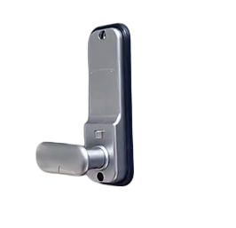
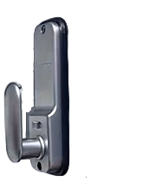

To Disable the Stay-Open Function: Press and hold the rear door handle. Then, push the rear door positioning switch in the door-opening direction and release the door handle. The stay-open function is now successfully disabled.
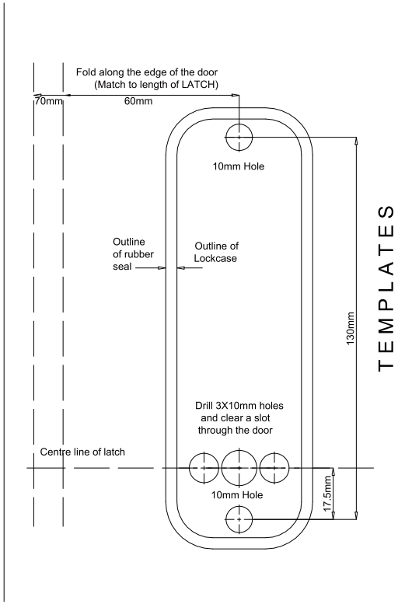
Manufacturer: Shanghaimuxinmuyeyouxiangongsi
Address: Shuangchenglu 803nong11hao1602A-1609shi, baoshanqu, shanghai 200000 CN.
EC REP: E-CrossStu GmbH.
Mainzer Landstr.69, 60329 Frankfurt am Main.
UK REP: YH CONSULTING LIMITED.
C/O YH Consulting Limited Office 147, Centurion House, London Road, Staines-upon-Thames, Surrey, TW18 4AX
Imported to AUS: SIHAO PTY LTD.
1 ROKEVA STREETEASTWOOD NSW 2122 Australia
Imported to USA: Sanven Technology Ltd.
Suite 250, 9166 Anaheim Place, Rancho Cucamonga, CA 91730

Technical Support and E-Warranty Certificate
www.vevor.com/support

